

THE GREEN JUICE RACK

**EXECUTIVE SUMMARY**

Hi, I am Amethyst Lowe and my company is The Green Juice Rack.

The Green Juice Rack solves for five key food service challenges for our students and faculty:

Access to nutrient dense fresh produce, the need to know where our fresh produce comes from, what is in our produce, cost of fresh produce, and the safety of the fresh produce.

Now that schools have opened and we can congregate and fellowship with one another on campus, I have noticed the caution and self-care and health-conscious culture that my peers are engaged in. We are concerned about boosting our immune systems with natural nutrition while maintaining a balanced budget. It is common now to find an OleMiss student with a jug of water or smoothie than a can of soda.

The Green Juice Rack customer is a student or faculty who is mindful of their health and budget who is in search of the most nutrient dense natural nutrition. The Green Juice Rack has managed to pack 27 pounds of live nutrient dense microgreens in a 3 ft x 2.5 ft x 6ft rack. This small foot print allows The Green Juice Rack to fit into most campus cafeterias and recreation centers.

We will rent a space at the cafeteria at $100 per week. This location will allow us to service our students and faculty with the freshest live nutrient dense microgreens that is harvested at the time it is ordered.

**HIGHLIGHTS**

|  |  |  |  |  |  |
| --- | --- | --- | --- | --- | --- |
| **MICROGREENS PROFIT ANALYSIS** | | | | | |
|  | **Mustard Green** | **Mustard Red** |  |  |  |
| **COST** |  | |  | **TOTAL TRAYS ON RACK** | |
| Seed/Tray | $0.50 | $0.50 |  | 27 | |
| Coir Soil/Tray | $0.45 | $0.45 |  |
| Labor/Tray | $2.00 | $2.00 |  |  |  |
| Electricity/Tray | $0.40 | $0.40 |  | **NET RACK REVENUE** | |
| Total Cost/Tray | $3.35 | $3.35 |  | $450 | |
|  |  | |  |
| **REVENUE** |  |  |  |
| Yield/Tray (ounces) | 16.00 | 16.00 |  | **DAILY JUICE SERVED** | |
| Price Per Ounce | $1.50 | $1.50 |  | **100 CUPS** | |
| Revenue/Tray | $24.00 | $24.00 |  |
|  |  | |  |  |  |
| **PROFIT** | $20.65 | $20.65 |  |  |  |
|  |  |  |  |  |  |

**OBJECTIVES**

The Green Juice Rack plans to launch in the Summer semester to test the market and position the rack at the ideal location in the cafeteria or recreation center.

**MISSION STATEMENT**

The Green Juice Rack exists to service our campus students and faculty with the most nutrient dense microgreens at favorable cost.

**KEYS TO SUCCESS**

The Green Juice Rack will partner with the food services and recreation departments on campus to be sure that all our students and faculty get adequate access to the most nutritious juices.

If the COVID-19 pandemic has taught us one thing, it’s the importance of our health.

Juice bars are reported to grow at a rate of 7% a year yielding a higher scalability in the food industry due to lower labor and expenses. What makes The Green Juice Rack so special against the competition like Juva or Smoothie King. We are the first juice bar to have live growing ingredients with our Grow, Pick, and Serve blueprint. NO FOREIGN INGREDIENTS!!! FIT FOR EVERY DIET! Located right on campus.

We are currently in production of our own micro green growing racks in Memphis, TN as we speak.

Once our first batch of prototypes trials are completed one of our partners, a global leader in cloud computing will consider providing more of the racks.

The Green Juice Rack. Coming to a campus near you.

**Microgreens Nutrition Profiles**

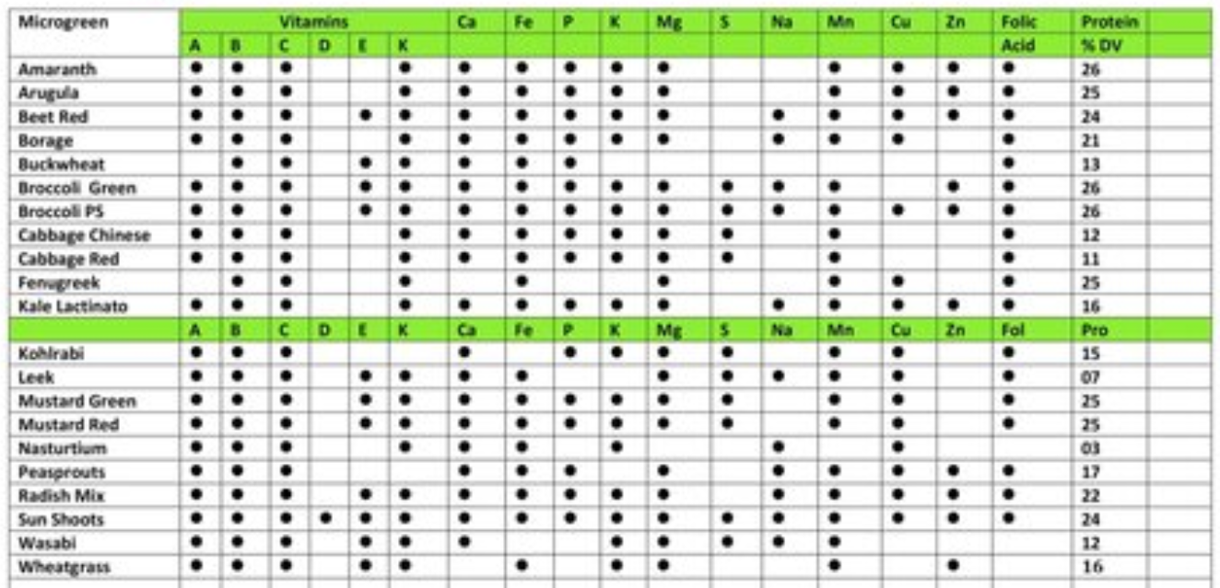

**MARKET ANALYSIS**

The Green Juice Rack plans focus on the Ole Miss student body and faculty as a test market. We have more than twenty thousand students on campus, we can capture 5% of the student body as our loyal customers. Our focus and competitive advantage is on serving live, harvest on demand ingredients for the most nutritious juicing experience. We will scale up at 5% market capture per year by adding more green juice racks in different congregation areas on campus.

By positioning our Green Juice Racks in the cafeteria, we will be able to convert 100 sales per day due to the high foot traffic volume in the cafeteria.

Our competitors are using plant powder to make the juices for their customers. We will be competing against Smoothie King, Tropical Café, and Juva.

Our customer retention strategy will entail juice prep subscriptions and wellness/ fitness tournaments. We will utilize Shopify to not only establish a payment reconciliation system but also to market The Green Juice Rack health/wellness culture on merchandise.

Our profitability is based on selling 100 cups of Juice in a 5-hour lunch period. The more we grow, the more profitable our margins. The Green Juice Rack is one of the best solutions for a campus setting.

Feed the students with the most nutritious juice and observe the academic achievement improving with every cup!!

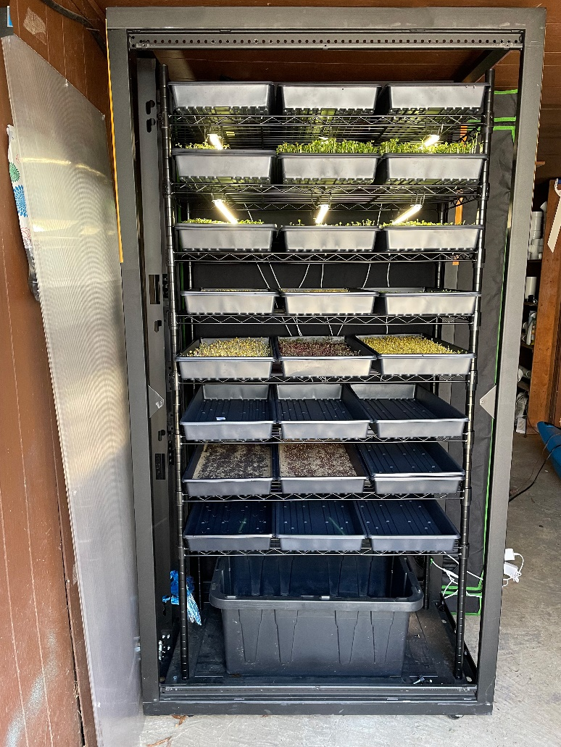

|  |
| --- |
| **TOTAL TRAYS ON RACK** |
| 27 |
|
|  | |  |
| **NET RACK REVENUE** |
| $450 |
|
|  | |  |
| **DAILY JUICE SERVED** |
| **100 CUPS** |
|